Starforge Printing is a platform where anyone can go to get quality 3D prints just by uploading an STL. You choose what material you want your model printed in and a quote will be sent back with a list of different quantities and the prices for each. The project is self-acquired since our Etsy shop has seen great success selling 3D printed items and custom prints are in high demand.

Research
- Treatstock- Middle man platform that offers 3d printing, cnc, and cutting services. There are reports that this company takes a long time to send payouts to customers if at all.

- Craftcloud- A broker platform that connects users with companies who provide 3d printing cnc machining, metal fabrication, and casting/molding services. Prices vary depending on want company you ultimately chose for your project.

- Shapeways- Offers CNC machining, 3D printing, and wax casting. Generally, a popular and trusted service that has only improved since it was taken over by new management last year.

Use Cases
- Create Account
- Login to account
- Delete account
- Upload STL
- Request Quote
- Make payment
- Order Tracking
- Cancel Order
- Adjust model infill strength
- Adjust model outer wall layers
- Order status
- Report order issue
- Adjust order quantity
- Edit product name
- Adjust model scale

WBS
- Frontend
1.1 Account Management
- Create Account
- Login To Account
- Delete Account
1.2 3D Model Management
- Upload STL
- Adjust Model Size
- Adjust Model Strength
1.3 Order Management
- Make Payment
- Track Order
- Request Cancellation
- Backend
2.1 Payment Processing
- PayPal Integration
- Tax Collection
- Shipping Calculation
2.2 Authentication
- Login Storage
- 2FA
- Login History Log
2.3 3D Model Processing
- File Storage
- 3D Model Auto Slicing
- Price Calculation

Gantt Chart
ID | Name | Week 1 | Week 2 | Week 3 | Week 4 | Week 5 | Week 6 | Week 7
1.1 | Account Management
1.2 | 3D Model Management
1.3 | Order Management
2.1 | Payment Processing
2.2 | Authentication
2.3 | 3D Model Processing

Backlog
-Login
- Account Registration
- Account Login
- Change Password
- Account Logout
- Account Deletion
-Ui for operator and user
- Homepage
- About Us
- Account Setting
- Upload STL Page
- Adjust Model Size
- Adjust Model Color
- Adjust Model Strength
- Get Model Quote
- Cart
- Payment Screen
- Order Tracking Screen
- Contact Us page
- Uploaded Models Page
- Quantity Selection Widget
- Quote Approval Screen

-Backend processes for operator and user
- Account Storage
- 3D Model Storage
- Quote Storage
- Quote Calculation Service
- Messaging Service
- 3D Model Slicer
- Shipping Calculation
- Price Calculation
- 2FA
- Order Payment Processing
- Order Tracking Updater
- Refund System
- Refund Processing
- Email Notification Service
- Review System
- Inventory Updater
-Reporting for operator and user
- Order History Log
- Login History Log
- Earnings Report
- Uploaded Models Report
- Messaging Report
- Delivery Report
- Review Report
- Traffic Report
- Print Success/Failure Report
- Print Completion Time Report

Risk Factors
- Technical
- File compatibility- Customers may upload outdated or corrupted STL files
- File Security- Customer STL files could be compromised in a security breach
- Slicing Failure- The slicing programs may not use the right settings when converting the model to a printable object
- Quote Failure- The quoting system may not give an accurate estimate for the
- Schedule
- Print Delay- Do to failures or a surplus of order, prints may not make it out on time before the due date.
- Testing Delay- Printers might fail during the testing phase
- Implementation Delay- Implementation of the payment or quoting systems may take longer than expected
- Launch Date Change- Stockholders may request that the launch date be moved
- Financial
- Slicer Software Licenses- Software licenses may need to be purchased for slicer integration
- Security Costs- Security costs could increase as development progresses
- Storage Costs- File storage needs will increase with more customers
- Shipping Costs- Shipping costs may fluctuate greatly between different locations and seasons
- People
- Developer Absence- Developer could be absent or quit during a critical time
- Unskilled Developer- Developer may not be as skilled as advertised
- Developer Communication- Developers may not communicate effectively causing the same work to be done by multiple different
- Requirements- Stakeholders may take long to specify requirements, especially for new developments

Risk Register
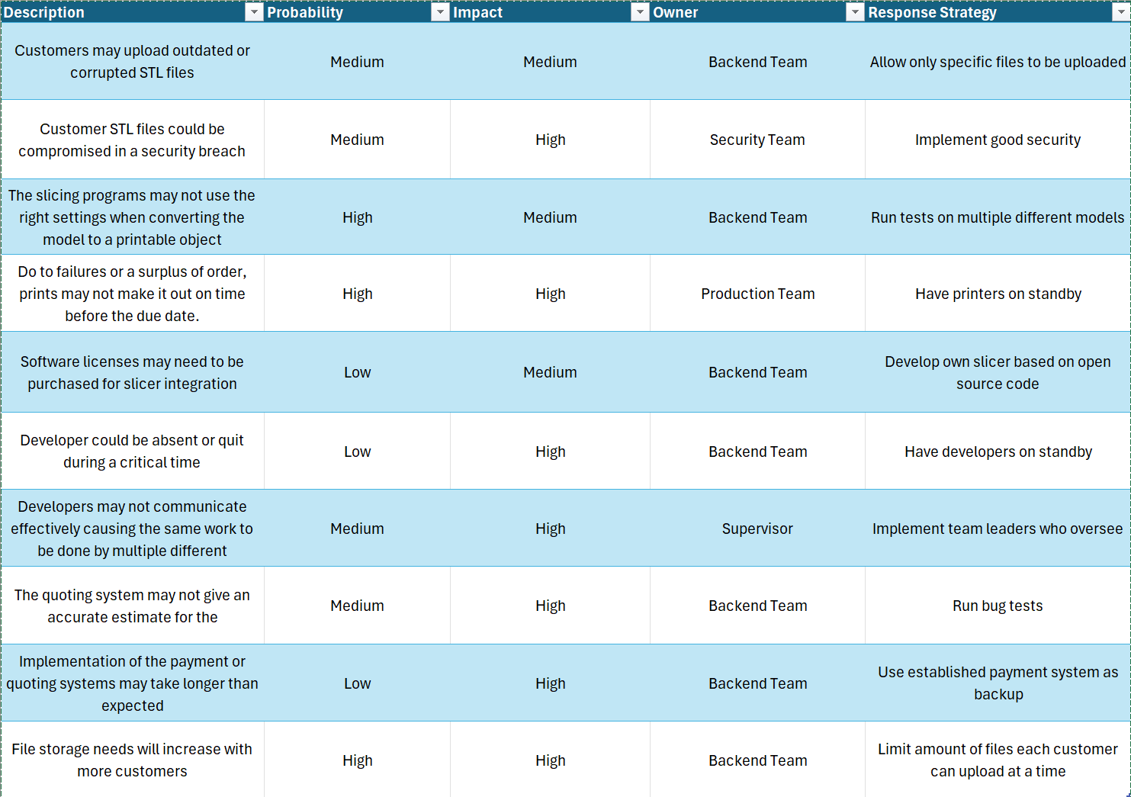

Communication Plan
Backend Team- Meetings held twice a week on teams
Production Team- Meetings held weekly in person
Security Team- Meetings held bi-weekly on teams unless there’s an emergency
Supervisors- Meetings held weekly on teams

